You Do- Explicit
Jamestown and Slavery
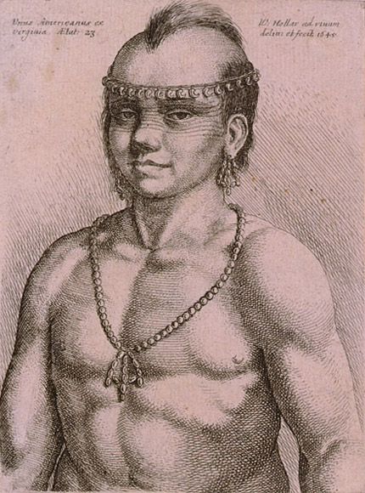
An event of momentous consequence took place in 1619, when a Dutch slave trader exchanged a cargo of captive Africans for food. The Africans became indentured servants, trading labor for shelter and eventual freedom. They were among the first African Americans in the colonies. Racial slavery would not become a common occurrence until 1680. For all, the struggle for land and survival continued, but Jamestown was just the beginning.

